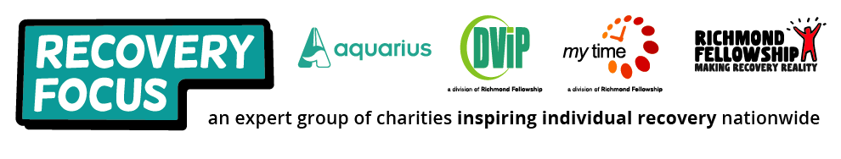
VOLUNTEER APPLICATION FORM
Thank you for expressing an interest in volunteering with Recovery Focus. We provide a wide range of mental health, substance misuse, and other complex needs support services. Please complete this form as fully as you can and return as requested on the final page. All the information provided within this application and in any further DBS check will be treated as confidential and will not be passed to anyone outside of the organisation without the applicant’s permission.

Section 1 - Personal Information:
First Name: | Surname:
Title: Mr / Mrs / Miss / Ms / Dr / Other | Gender: Male / Female / Prefer not to say
Home Address:

Mobile Telephone No: | Home Telephone No:

Email Address:

Date of Birth: | Emergency Contact:

Current Occupation (if applicable):

Section 2 – Areas of Interest
Please mark with X against any of the following areas that you are interested in, have skills in or would like to help others with:
Animals/Pets |  | Arts/Crafts |  | Befriending |  | Book Keeping/Finance
Cooking/Catering |  | Computers |  | Databases |  | Driving/Transport
Environment Projects |  | Exercise/Sports/Fitness |  | Film/Cinema/Theatre |  | Gambling
Gardening |  | History |  | Health |  | Home Help
IT/ Internet |  | Languages |  | Listening |  | Making phone calls
Meeting people |  | Mentoring/Teaching |  | Music |  | Office Admin
Painting/Decorating/Repairs |  | Photography |  | Reading |  |  | Relaxation
Substance Misuse |  | Travel |  | Walking |  |  | Writing
Other Interests:

Section 3 – Availability
How many volunteering hours per week would you be able to fulfil? …………………………………..
Please X the boxes to show your availability at present:
Mon |  | Tues |  | Weds |  | Thurs |  | Fri |  | Sat |  | Sun
AM | PM | AM | PM | AM | PM | AM | PM | AM | PM | AM | PM | AM | PM
If you have complete flexibility please X this box

Section 4 – Experience & Personal Qualities
Please tell us why you are interested in becoming a volunteer with us:

Please give details about any relevant hobbies or interests:

Please give brief details of any previous paid or unpaid work experience relevant to any particular support services offered?

What do you see as your main qualities and strengths for volunteering with us?

Have you completed any relevant training which would support your application? If so, please give brief details:

What further training would be helpful for you and do you have any additional support needs that we should be aware of:

Please provide any further helpful personal information you are happy to share at this time:

Section 5 – Disclosure of Criminal Convictions
You will appreciate that we are responsible for the provision of services to vulnerable people and therefore must be particularly careful to enquire into the character and background of Volunteers. By virtue of the rehabilitation of offenders act 1974 (Exceptions) Order 1975, this work is exempt from the provision of the said Act. You are therefore obliged to give details below, of any previous convictions and cautions:

Section 6 – Character References
Written references are required for all volunteer applicants, so please supply the names and contact details of two individuals who know you well but who are not in your family, and who you are happy for us to contact:
Detail | Reference 1
Name:
Relationship to applicant:
Position or Title:
Telephone Number:
Email:
Address:
Detail | Reference 2
Name:
Relationship to applicant:
Position or Title:
Telephone Number:
Email:
Address:

Section 7 – Declaration Agreement
I confirm that, to the best of my knowledge, the information I have given in this application is correct.
Signed by applicant: | Date:
Signed by staff member: | Date:
For Official Use Only:
Date application received: ___/___/___ Date individual contacted: ___/___/___
Date of assessment meeting: ___/___/___ Date assessment meeting completed: ___/___/___

Approved / Not Approved / Query

Please return this completed application form (with cv if available) to:

